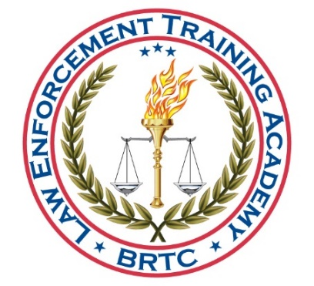

BLACK RIVER TECHNICAL COLLEGE
LAW ENFORCEMENT TRAINING ACADEMY

WAIVER OF LIABILITY and INFORMATION

For being allowed to participate in ANY TRAINING at the Black River Technical College Law Enforcement Training Academy, I, hereby release and hold harmless the State of Arkansas, the Black River Technical College Law Enforcement Training Academy, and all persons associated with this course, from any and all liability for injuries I might receive during this training.
I further understand that the training is physically demanding and that I have completely and accurately reported any and all medical conditions as required on the Commission on Law Enforcement Standards and Training (CLEST) Medical History Questionnaire and have been examined by a physician and found to be in good health and physically able to undergo this course.
I also acknowledge that I am personally responsible for any and all medical expenses I might incur while attending this course.
I authorize Black River Technical College Law Enforcement Training Academy to release to my employing agency, for employment purposes, any and all records and information, whether oral, written, or electronic, regarding my performance, health, academics, injuries, and conduct. I understand that I have the right, upon request, to receive a copy of any records disclosed, unless otherwise prohibited by law.

Applicant’s Printed Name:

Applicant’s Signature: Date:

Supervisor’s Signature: Date:
(If attending as an exempted Veteran, a spouse or other witness may sign.)

